2-14 Swift Street, Wellington.
2017 occupied by National Australia Bank
by Marie Hoffman
The first recorded owner of this Swift Street land is James Drew, he had a garden, then built Wellington’s first store on the site c 1850.
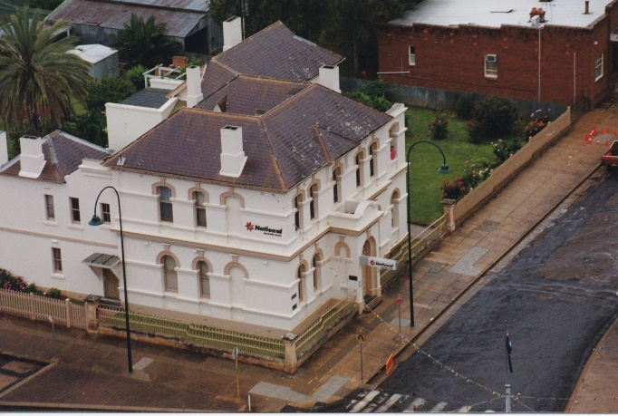
The Commercial Banking Company, established in Sydney opened its doors in Sydney, for the first time on 1st November 1834.
The Wellington Branch opened 5th June 1876 in Lee Street, as reported in Australian Town and Country Journal Saturday 10 June 1876 “We have a new bank in town now. Mr. Barton, late of Parkes, is the manager of the Wellington branch of the Commercial Bank just established. The business is done at present in a room given by Mr. W.G. Way, of the Vectis Stores, and I hear an allotment has been purchased from Mr. Gardiner in the front street, so I expect we will soon have a new bank built.”
Charles Hampden Barton (1848-1912). Charles Barton was born at Boree in 1848. He was the third son of Robert Johnston Barton. He spent his childhood at Boree Nyrang near Molong, went to Carcoar School. He later became a pupil at Windsor.
In 1868, Charles joined the staff of the Commercial Bank at Sydney. He had a successful banking career. By the time he was twenty-eight, he had been appointed to open branches at Tambaroora at the time of the gold rush and at Parkes and Wellington.
Opening a bank branch in those days was no sinecure, and Mr. Charles Hampden Barton arrived in Wellington with the requisite coin in a handbag, opening business in a room secured in a private residence. There was no safe, so it was an appointment of responsibility and anxiety.
 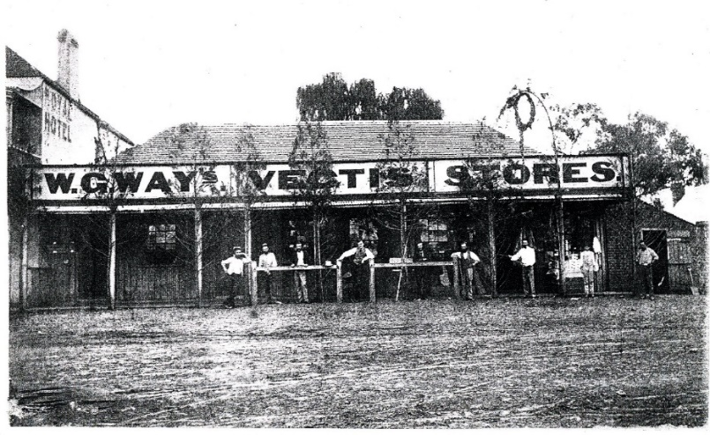
Charles H. Barton Original Vectis Stores, which were burnt in a fire and two-
storey brick building erected.
Photo courtesy Wellington Historical Society Inc
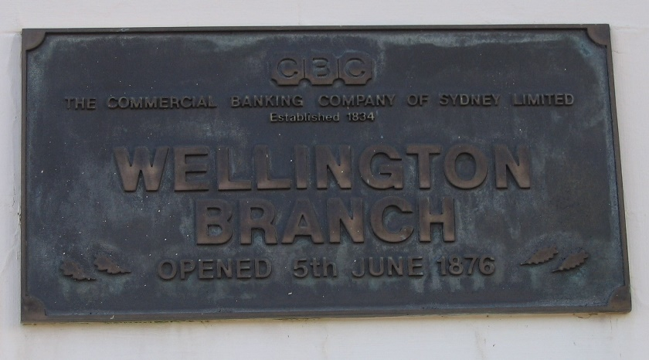
In December 1877, The Australian Town and Country Journal reported that “Way’s Vectis Buildings, housed the Commercial Bank, a very decent-looking drug store, a saddler’s shop and the Gazette printing office. These are the neatest-looking buildings in town.”

About 1878, the Bank office was removed to the new two-storey premises in Nanima Crescent erected by Dr. Rygate. (2017 Keirle’s Pharmacy).
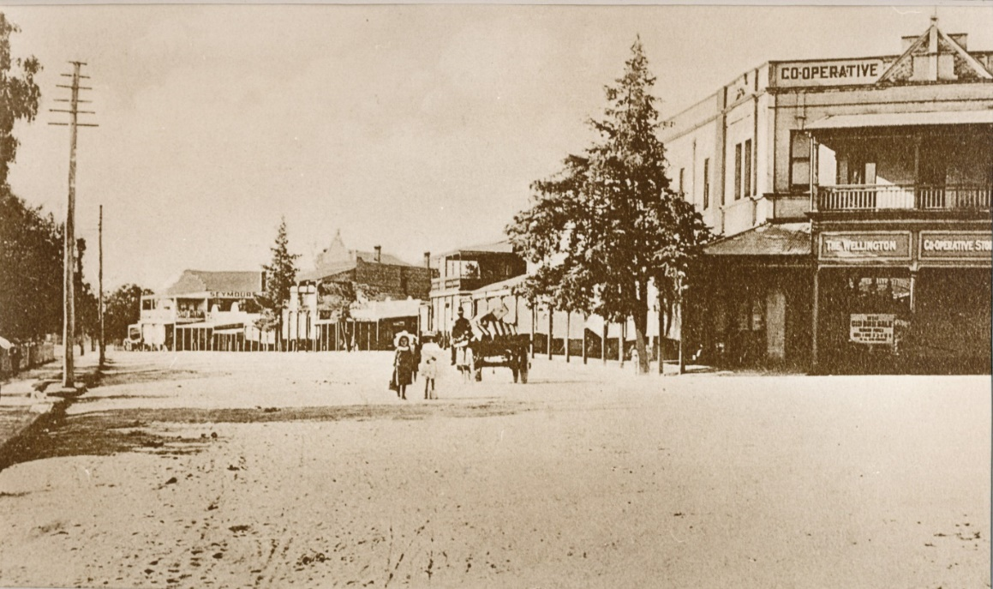
Nanima Crescent, 1904 – would be after the Bank left the premises.
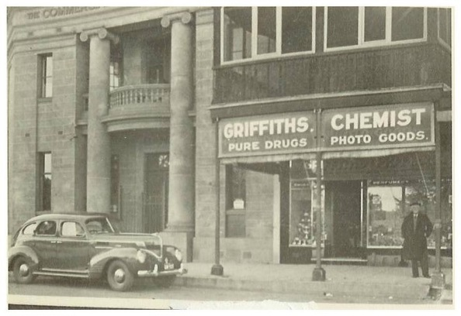 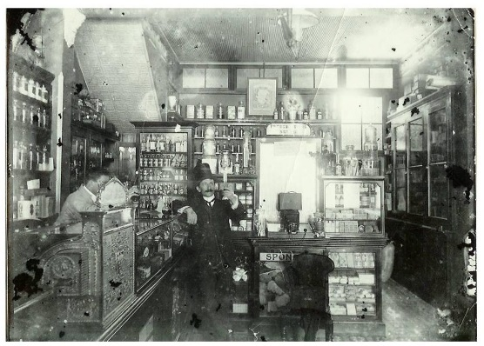
This photo of the Nanima Crescent premises c1900 interior of Pharmacy building.
was taken in 1935, so it may have changed.
Land at 2-14 Swift Street was purchased October 20, 1881 and building commenced in December 1881.
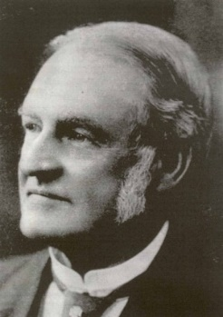
The new bank was designed by prominent architect, George Allen Mansfield.
It was built at a time of progress and prosperity in the town and district. The bank was an outstanding example of the Victorian Italianate style of building and is aesthetically pleasing as well as forming an integral part of the streetscape. The size and importance of the building emphasised the confidence felt by the local community and outside business in the
George Allen Mansfield future of the district.
The building was completed in 1883. The Manager’s residence, upstairs, featured a spacious veranda on the eastern side overlooking a large garden.
In the 1930s Swift Street was a hive of activity as many new buildings were constructed. George Wilkins built his Stock and Station Agent’s office at No. 16 Swift Street. Mr Wilkins also owned the next-door block which he sold to Mr. McAtamney and upon the completion of the sale and the construction of the McAtamney building, Mr Wilkins had no rear entrance to his property so negotiated with the Bank to purchase a small section to provide the access necessary.
Former Commercial Bank of Sydney Ltd (C.B.Co.) employee, Mrs Pat Jordan nee Simington, had been working in the office of Wellington’s Glove Factory when she was offered a position at the Bank, which she accepted. She recalled that when she was the junior, she opened the doors for business at 10.00am sharp, collected the mail from the Post Office, collected morning tea which could include small delicious cakes from Russell’s bakery and operated a small switch board with brass plugs. Mr Burge, the Manager, Gerry Collins, the Accountant and the upstairs residence had their own telephones.
The staff at the time was the manager, accountant, teller, a junior and three ledger keepers. One ledger keeper was always a male who would drive to Geurie twice a week (Tuesdays and Thursdays) with satchel and revolver. Pat said that Mr. Collins was usually the person who did this while she was there. At one time, Geurie had its own branch, but it closed. From memory, Pat thought that Mr. Collins may have been the manager there.
The “Exchanges” were held daily at the Commercial Bank of Australia. Each Bank, Rural, Bank of New South Wales, Commonwealth, A.N.Z., and C.B.Co. would send a representative with a satchel containing cheques presented at their bank. The cheques would be in bundles for each bank and a total shown. These bundles were then exchanged and returned to the respective banks, sorted and processed by the ledger keepers.
Later Pat became a ledger keeper/typiste and started looking after the smallest (Q-Z) ledger. The other ledgers were A-F and G-P. The ledgers were great big leather covered books and the ledger keepers hand wrote with black and red ink. The next morning, after the entries were scribed in the ledgers, they were checked, known as “call up the ledger”, this was done either with the accountant, or manager. Any overdrawn accounts were noted and referred to the manager. This process was always completed before doors opened for business at 10.00am.
We had a “beaut” adding machine. It was about three-foot-high with a handle on the side and a wooden side table.
An outside door, opened from the manager’s office to the verandah. People who were “in trouble” (over-drawn) used this door to speak with the manager, who sometimes took them for a drink.
The town had a Bankers’ Club which staff from all banks participated. The Bank of New South Wales had larger staff numbers than the C.B.Co. The different banks would challenge each other at lawn bowls and would use the banks revolvers to shoot at the shooting range. On social days, such as the Bank Holiday, they played tennis.
She remembers that the bank had a set of Gold Scales which were used when the Chinese Gold miners came into the Bank with their findings. The counters were solid cedar. The banking chamber was heated by open fire places.
Over the years several name changes have taken place.
The most significant when in 1981 the Bank merged with the National Bank of Australasia Ltd, shortened and now known as National Australia Bank.
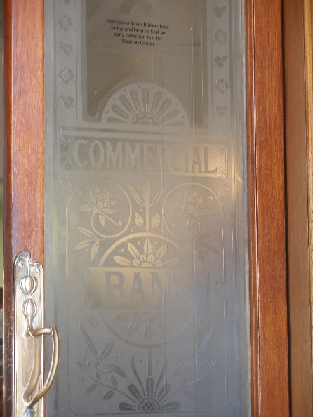
During the 1980s, the historic Wellington building was restored. Restoration was estimated to have cost about $1.2 million over an eight-year period leading up to the bicentennial year of Australia in 1988. Included in the restoration and extension were new staff facilities, change rooms and kitchen.
During renovations, the timber-framed double glass doors were removed and replaced by a single glass sliding door.
The building was sold to private investors, the latest in September 2015. It continues as National Australia Bank. The upstairs residence has been rented to private people.
Photo courtesy John Ness.
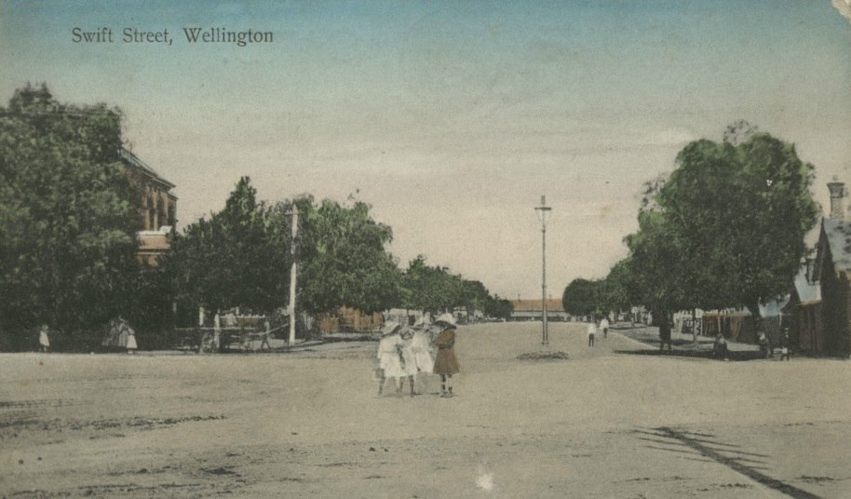
Swift Street, 1913.

